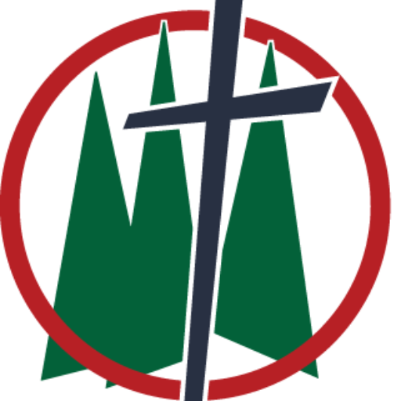
Trinity Lutheran Church
8th Sunday After Pentecost
Date: July 19, 2026
Reading: Isaiah 44:6-11
Theme: God Has No Equal
_____________________________________________________________________________________

Are you steady? Are you secure? Are you stable? A feeling of safety is something that every person on planet earth desires, young and old. Everyone looks in different places and to different things to find safety and security, but bottom line—it’s a desire that all people have. And that desire for safety and security will quickly display who or what your true god is. We live in a world where people are constantly looking for something solid to hold onto. There’s all sorts of economic uncertainty, political division, rapid advances in technology, and endless streams of information that leave us wondering what or whom we can depend on. In many ways, we are prone to placing some level of confidence in our careers, investments, government, achievements, or even popular trends. Yet, all those things can and often do change overnight, in the blink of an eye. What made me feel secure yesterday might leave me terrified today. The people of Isaiah’s day had similar temptations. They were surrounded by powerful nations and countless idols; they were encouraged to believe that security could be found in something they could see, touch, or control. But through Isaiah, the Lord cuts all that thinking and temptation down. The word we read this morning isn’t just an ancient argument against idols carved out of wood by hand. It is God’s timeless reminder that anything we trust more than him becomes an idol. Whether our idols are made from wood and stone or built from money, success, entertainment, reputation, or self-reliance, they all make promises they cannot keep. Only the Lord stands outside of time, rules over history, and keeps the promises he makes. Which means this God, your God, has no equal.

To show that he has no equal, God does a positive assessment of himself and a negative assessment of everything else that could possibly fill that God shaped hole in everyone’s heart. How does God often tell us about himself? With names and titles. He gives us four specific ones this morning: The King of Israel, Israel’s Redeemer, The Lord of Armies, The First and The Last. It’s easy to read through the Old Testament and gloss over the different things God calls himself because he’s just growing his word count; wrong. God’s Word is the means by which he makes salvation known to us, which means he’s fully intentional in his word choice. So we’re taking a look at each. The King of Israel. We don’t function under a monarchy, we don’t have kings and queens in America. Israel, for much of its history lived under a monarchy. But what they failed to realize was that their desired monarchy never really became a monarchy. Israel was formed under a theocracy—God was the king. When Israel begged for a king, God knew he had fallen from the throne in their hearts, but he had not fallen from his throne in heaven and on earth. I am the King of Israel. And even though he had and has people who do not listen to or obey him as king, he still sits upon that throne, not as a dictator or twisted king, but as name number two, Israel’s Redeemer. Israel had become slaves in two ways—to their sin and to their enemies. To redeem something is to buy or trade something for similar value. As the redeemer of his people Israel, God would be the one who would pay for what they had done. Hence, Scripture defines the Son of God as the redeemer of mankind. The precious blood of Christ would and has paid for the sins of the whole world. The redemption of Israel, of all people, cost God greatly, and redeemer is a title he wears proudly.

The last two names more so describe attributes or qualities of God. Lord of Armies. Adonai Tzevaote. This is one name for God that is often translated differently depending on the Bible you’re reading. This morning we read Lord of Armies. Some translate Lord of Hosts, some translate Lord Almighty. They’re all proper translations and all provide a different flavor of God’s purpose: I am powerful—more powerful than anyone or anything you have ever known. Additionally, this is the name Jehovah, the God of free and faithful grace. The God of the covenant he made to Abraham—a covenant of his love. He puts the two together in a way that shows that he uses his unlimited power in many ways, but the most important use of his power is to keep his promises and to save his people from their sin. Finally, I am the first, and I am the last. We’re reminded of this characteristic of God every time we step into this sanctuary: it’s up on the altar. To the left you see the Greek letter alpha; to the right you see omega. The first and last letters of the Greek alphabet. That’s the verbiage Jesus gives to John in the book of Revelation, but it’s the same truth God proclaims through Isaiah: before anything was, I am. God did not emerge amongst the history of the created world. He is independent from creation because he created all things! When there was nothing, God was there. When all things come to an end, God will be there. When the last person on earth to hear the gospel hears it, and Christ comes again, God will be there. There is never a time or place when and where God is not present. Why does he share these things about himself? Because each of these names stand in complete contrast to the idols that mankind is notorious for making for itself. These names are proof that God has no equal.

The Lord declares: Who is like me? Let him declare it. Is there any god except me? There is no other Rock. I am not aware of any other. You can almost hear God chuckling as he says these things and yet the seriousness behind these words is startling. This is the number one problem that people have. We have this desire to look to creation for that which only the Creator can give us. Hear Paul’s words in regards to people who fall into idolatry: So, as they followed the sinful desires of their hearts…such people have traded the truth about God for the lie, worshipping and serving the creation rather than the Creator, who is worthy of praise forever. Just think about the name. There is no person who will ever rule over you, provide protection for you, or give you everything that you need for your body and life better than God your King. There is no one, not your mother, your spouse, your children, your pastor, your best friend, who can show you the love that caused God himself to abandon his Son on the cross at the mercy of sinners, who suffered and died in the place of sinners for the slavation of sinners. There is no person alive who can create anything out of nothing; who can cause things to exist out of nothing. Who can part the waters of a sea, who can cause an unbeliever to believe, who controls legions of angels; no one on planet earth has the power of your God. And no one can outlast him. No one knows what he knows. No one does what he does. No one has seen what he has seen. There is no one, there is nothing, that comes close in comparison to our God. Yet, our sinful hearts try to make it so.

In the ancient world, fashioning idols from materials was common. You could walk into any given home and probably find statues and shrines to different images of gods carved by sinful human hands. That was normal for people. Normal doesn’t mean good or right. We don’t see as much ancient idolatry today, but, oh, is it present. It is normal to work night and day building a career or maybe a family that anyone would be proud of. It would be normal in our world to spend too much free time catching up on politics and world events. It would be normal to subscribe to all the ways we can watch sports, or spend all our time getting the kids through their sports. It would be normal to dream about the good ole days and all the great and wonderful things you accomplished. It would be normal to talk about your kids and grandkids as if no one could compare to them. It would be normal to do things that make you happy at the expense of other people in your life. It would be normal to pretend that our words and actions don’t truly effect other people. All of these things would be normal. But normal isn’t always good. You live in a sinful world with a sinful heart which means normal is tainted and twisted by sin in every way possible. And every time we put anything “good” in this world above our God, we make that thing or that person our personal idol. Take an inventory this week of the places you put your money, the things on which you spend your time, the places you find yourself going to the most, and ask yourself, is God number one in my life? If we honestly ask that question, the answer will be no. And if the answer is no, we need Isaiah’s warning: All those who form an idol are good for nothing. All the things which delight them provide no benefit.

Almost all of the things I mentioned are blessings and gifts from God, but recognize that—they’re from God! We can get so caught up in the gifts that we forget all about the giver; don’t! God loves to give you good things—things you need and things you want—but the last thing he wants is to find himself at the bottom of your list of priorities. That is not where he belongs. We were and always are God’s priority, he proved that on the cross. His Son suffered and died for all the idols and gods that we have created for ourselves. For all the times our priorities were and are messed up. For all the times we knew that God did not have the number one spot in our hearts. He knows that about you, and he loves you unconditionally anyways. When we create idols for ourselves out of the good things God gives us, he knows that can cause us to fall away from him. Go home this week and have an honest conversation with yourself or around the dinner table and do two things: one, be reminded that God always puts you first above himself—his crucified and resurrected Son is proof of that; two, find the things that you put before him and rearrange your priorities. Nothing that God has created for you can give you the love and security that you find in him, because your God has no equal. Amen.

