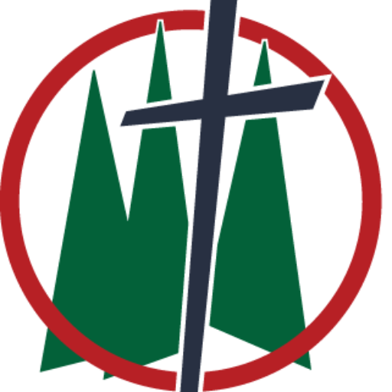
Trinity Lutheran Church
Easter 5; Confirmation Sunday
Date: May 3, 2026
Reading: Acts 4:8-12
Theme: Confirmed By Christ
_______________________________________________________________________________
Simon Peter is one of the most relatable figures in all of Scripture—a disciple whose life is marked by soaring highs and crushing lows. When Jesus first calls him from his nets, Peter leaves everything behind. There is an immediacy to his faith, a boldness that seems unshakable. And at times, it really does shine. Peter steps out of the boat and walks on water at Jesus’ command—something no other disciple even attempts. When others are confused about who Jesus is, Peter speaks clearly and confidently: “You are the Christ, the Son of the living God.” But Peter’s story doesn’t stay on the mountaintop. The very man who walks on water begins to sink when his focus shifts from his Savior to the wind and waves. The disciple who confesses Jesus as the Christ soon turns around and rebukes him for speaking about the cross. His confidence is real—but it is often misplaced, rooted more in himself than in his Lord.
And then we come to Peter’s lowest moment. On the night Jesus is betrayed, Peter insists that even if everyone else falls away, he never will. Yet only hours later, standing in the courtyard of the high priest, Peter denies Jesus—not once, but three times. The rooster crows, and Peter, the rock, makes eye contact with Jesus as he’s being led away toward his death, and Peter crumbles beneath the weight of his betrayal—the betrayal that he promised would never come. If Peter’s story ended there, it would be a tragedy. But it doesn’t—because Jesus does not give up on Peter. After the resurrection, Jesus seeks him out, not to shame him, but to restore him. Three times Peter denied his Lord; three times Jesus gently called him back: “Feed my sheep.” Peter’s standing with God is not rebuilt on his own promises, but on Christ’s forgiveness. And that changes everything. By the time we reach Acts 4, Peter is standing before the same council that condemned Jesus. But now there is no fear, no denial. Filled with the Holy Spirit, he boldly proclaims, “Salvation is found in no one else.” The difference is not that Peter has finally become strong enough. The difference is that Peter has been broken and rebuilt by grace. And that is where Peter’s story meets ours. We have plenty of highs and lows in our lives of faith. We have moments of confidence and moments of doubt. But like Peter, we are not defined by our worst moments. We are defined by Christ’s mercy. The same Savior who called Peter, forgave Peter, and confirmed Peter is the same Savior who calls, forgives, and confirms us.
This morning, we listen to the words of this same Peter about the same Savior, and we recognize two things: 1) We have to be confirmed IN Christ, and 2) we have to be confirmed BY Christ. Acts 4 is another moment in Peter’s life and ministry that proclaims the greatness of God. Notice, Peter addresses the Rulers of the people and elders of Israel. Do you know why Peter denied Jesus the night he was arrested? Do you know why Jesus found him with the disciples cowering in the upper room? Because he was deathly afraid of what would happen if the rulers of the people and the elders of Israel found him! And now, Peter and John are on trial for proclaiming Jesus’ resurrection from the dead and healing people in his name. He’s no longer hiding behind closed doors, no Peter stands on trial because the Jesus whom he denied, is the Jesus who went and died for him. And not only does he confidently stand before the rulers of the people, but he says this: This man was healed… by the name of Jesus Christ the Nazarene, whom YOU crucified, whom God raised from the dead. This Jesus is the stone that was rejected by you builders, which has become the cornerstone. I think bold would be an understatement when describing Peter before the council of Jewish leaders. The men who took a figure that everyone loved, a man who healed the sick, gave blind to the sight, proclaimed the love of God, and successfully crucified him on a tree, were the men whom Peter stood before and he says you killed him! Not only did you kill an innocent man, you killed the Son of God. And not only did you kill the Son of God, you killed the very cornerstone on whom you were supposed to be built!
Peter calls them builders—they were responsible for building the people of God upon their Savior and instead they killed him. The question that needed to be addressed was this—in what or who did they place their confidence? It wasn’t in the promised Savior—they put their trust in themselves. Their knowledge. Their good works. Their morally upright lives. The Jewish leaders were confirmed in themselves. Their confidence; their eternity; their salvation were all built upon their personal righteousness, but they did not know they had killed the only way to salvation. Nothing changed for these leaders. They continued to live their lives thinking they could get themselves into heaven, and denying Jesus Christ as the Messiah and Son of God. But life drastically changed for Peter. Because Peter had been built upon that cornerstone. When building a structure, this is necessary—without a cornerstone, you don’t have a baseline, or a starting point for the rest of the building. One stone made sure the rest were straight and sturdy. If that one stone was wanky, the whole structure would be unstable. Yes, I understand architecture works a little bit differently nowadays than it did at biblical times, but the concept remains—without a sure foundation, a building isn’t going to stand. And if you build something upon a shaky foundation it is coming down at some point, you just may not know when. There’re a lot of texts from the Bible we could talk about on Confirmation Sunday, but Peter’s statements are particularly powerful this morning. Because this is the cornerstone on which you are built. This is the cornerstone on which God’s church is built. You, confirmands, will be confessing this cornerstone as the one on whom you are currently built and will continue to be built for the rest of your lives. Members of the church, this is the cornerstone on which you have claimed to be built for any number of years. You are confirmed in Christ! He is your salvation. He is your rock. He is your security. He is your comfort when life gets complicated. He is your safety when life becomes dangerous. Christ is your cornerstone and you are confirmed in him.
But what is as important as being confirmed in Christ is being confirmed by Christ. Peter says this: There is salvation in no one else, for there is no other name under heaven given to people by which we must be saved. I want to make this very clear. Your confirmation day is not about you. Your confirmation day is the day that you make a public confession, before God and your brothers and sisters in Christ, that Jesus himself has confirmed you and that you are confirmed in him alone. In a few minutes you will confess that you are saved by faith in Jesus alone. Which means you are also confessing the many things that you will not find your salvation in. This is a good reminder for all of us here. Salvation is not found in your ability to properly confess who God is and what he has done for you. Salvation is not found in your confirmation certificate. Salvation is not yours because your name is on the church roster. Salvation is not found in your kindness and goodness to other people. Your salvation is found in Christ alone. It is only Jesus who has confirmed salvation for you and it is only Jesus who confirms you in the faith that receives that salvation. With that in mind, don’t forget this. Confirmation does not mean that you’re set for life and never need to return to worship. Confirmation does not mean that you have learned everything Scripture has to say, so you never need to open your Bible again. Confirmation does not mean that you cannot fall away from your faith. The sinful heart in your chest does not want to be confirmed by Christ, it wants to go chasing after a pleasant life on earth. We’ve been talking about Peter this whole time; it would be fitting to hear one more thing he has to say: Your adversary, the Devil, prowls around like a roaring lion, looking for someone to devour. Satan isn’t after people who don’t believe in Jesus. Satan isn’t after those who are disconnected from Christ. He’s after those who have been confirmed in Christ. He’s after those connected to Christ. Satan wants nothing more than for this to be the last time you step foot in God’s house to worship him. Satan wants nothing more than for your Bible to collect dust at home, never to be opened again. Satan wants you to think that because you made a public confession of your faith in a church that faith will never fade away. But those who are not in regular contact with Jesus, his Word, and the sacraments are in grave danger of losing that faith. Which means we desperately need Jesus to confirm us in our faith so that it does not fade away.
We’ve been talking about the difference between graduation and confirmation the last couple of weeks, and it’s a question that each of these confirmands have answered. When you graduate from something, you’ve proven that you have the knowledge and you move on to the next chapter of your life—that looks different for everyone. But confirmation is a confession about what you have learned, and a promise to never stop growing. You are going to make promises to your God this morning; Promises to worship him here in his house as often as you can. You will make the promise to use God’s Word and the Lord’s Supper to strengthen your faith regularly. You will promise to share the saving message of Jesus Christ crucified with those who do not know or believe in their Savior. Today is a big day. Not because you’re done; but because you’re about to begin. You have been confirmed BY Christ, you are confirmed IN Christ. He is your salvation, now and forever. Amen.

