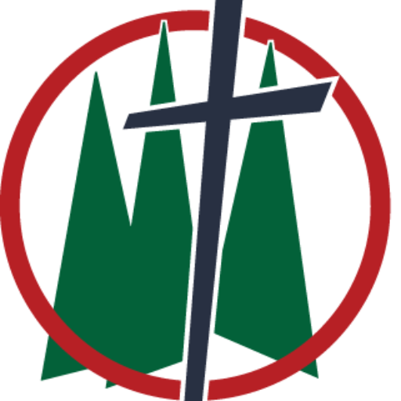
Trinity Lutheran Church
Fourth Sunday in Lent
Date: March 15, 2026
Reading: Isaiah 42:14-21
Theme: God Makes the Sinner See
_______________________________________________________________________________

God bless those who care for younglings. Whether that be in a professional or familial setting. Whether it’s in a school or in the home. I say that because being an adult and spending all day with those who are growing and learning to become adults is maybe one of the most taxing jobs people have. You will hear many people say that it takes a very special person to work with those littles. Our faculty at TLS is a prime example. Despite how many times little Susy needs to use the bathroom, or how many times Derek has to go through lesson 10 before he gets it, no matter how many times the same question gets asked over and over again, those who work with littles understand they need time to grow and learn—to learn what to do and not to do. The reason it takes a special person to work with those littles is because you need an incredible, far above average level of patience as they grow. Working with adults is a little bit different. They’ve done their learning and growing. They know what’s expected of them, yet when they live recklessly or sinfully, it’s much more frustrating to deal with because they should know better. With that in mind listen again to God’s Word: I have been silent for a long time. I have kept still. I have restrained myself. But now, like a woman giving birth, I will scream. I will gasp and pant. I will dry up mountains and hills. I will make all their grass wither. I will turn rivers into islands. I will dry up pools.

It kind of seems like God has had enough with his people. It’s not common, at least where I’m from, to say that I’m so frustrated about someone’s words or actions that I am going to scream out like a woman birthing a child. It may seem silly, but think about it, when it comes to the wayward, sinful lives of His people, God doesn’t just get frustrated, but it pains him. If you’ve ever lost a friend or a family member, not to death, but to some part of life, you might know a small part of the frustration and pain God feels. When you lose someone to death, there’s closure, it’s still painful, but as Christians we have peace. But if you’ve lost a relationship to sin—something happened between you and someone close to you—that’s the same as experiencing that loss but without the closure. That could be the epidemic of divorce. It could be a hidden lifestyle that was exposed. It could be a lifestyle that wasn’t hidden but has become a problem. Nonetheless, sin, whatever kind, corrupts relationships, and more often than not, we can’t see it. Spiritual blindness is a terrible condition we’re all born with and it’s a condition that tries to make its way back into our hearts time and time again. You and I have blind spots; sinful thoughts, attitudes, and actions that we often can’t see. In the Gospel we read this morning, Jesus compares physical blindness and spiritual blindness. What Isaiah does is he talks about two different types of spiritual blindness. There were those who couldn’t see the way to salvation—their life was one of hopeless ignorance—those who don’t know Jesus. Then there were those who knew God’s Word and Jesus, yet they rejected him and turned to their own ways in prideful arrogance.

For the first, I couldn’t help thinking about a small child in a big corn maze. The child goes running in, all excited, she’s gonna be the first one to get through the maze, but after a few wrong turns, she quickly finds herself lost. She calls mom and dad, and she knows they’re around, maybe she can even hear their voices, but she can’t see the way out—she doesn’t know where to go. In the same way, there are many, many people walking through life, they have no idea what’s happening, they have no idea where they are going, and more often than not, they have no idea the severity of their blindness. I just did some general statistics in catechism this week—there are 8.14 billion people on planet earth. 2.6 billion of those people claim the title Christian. ⅓ of the world’s population claims a connection to the one and only way to heaven. Furthermore, there are many of those 2.6 billion people who claim to be Christians who have no idea what that means. It doesn’t work exactly like this, but that would mean that roughly 2 out of every 3 people you run into in a day do not know Jesus. Well, this is what God promises: I will lead the blind on a way they do not know. Along paths they do not know I will direct them. Ahead of them I will turn darkness into light and rough places into level ground. These are the things I will accomplish for them. I will not abandon them. In his perfect wisdom God knows every single person that will live forever with him in heaven. He also knows most of those people are going to have a difficult journey in life. Every person here was born into this kind of blindness; a blindness that cannot see God. A blindness that cannot see what God commands, and a blindness that cannot see what the Savior has done. And oh, how life drastically changes when this blind person is given sight. When you were washed clean in baptism, you could see your God and Savior. You could see the life he has gifted to you. You were no longer blinded by the hopelessness of a sinful life. The life-saving, life-giving message of Jesus Christ takes that fear and hopelessness that blindness puts over our hearts, and fills us with peace and comfort as we fix our eyes on our Savior. God wants all people, all 8.14 billion to see their Savior from sin.

While those who are blind to the hopelessness of not knowing their God and Savior receive comfort and peace, those who blind themselves to that comfort and peace receive a stern warning. Deaf ones listen; blind ones watch carefully; You Israel, see many things, but you do not observe. Israel opens his ears, but he does not hear. Who is as blind as my servant; who is as blind as Israel? With the child you teach as you patiently wait for them to learn. With the adult you urge, remind, and even warn them to do what they already know. To those who know God, to those who have seen his grace in their lives, don’t go looking somewhere else for life and satisfaction. If you’ve ever been part of an intervention, you probably know how uncomfortable and frustrating it can become. This family member or friend is so stuck in their sinful way that no matter who sits around them or in their corner, they will not give their sinful lifestyle up. No matter how hard you try, no matter the amount of emotion you put into it, their blindness cannot be cured. What good is help if it falls on deaf ears. What good is the oasis if it’s seen and ignored. Don’t fall into the traps and snares Satan sets up; the very people through whom the Savior of the world would come lost sight of their God and the Messiah to come. We don’t have records, but many of those Israelites probably died without faith in their coming Savior—they knew he was coming, they knew they needed him, but they didn’t care and they lost sight. The same warning is for you and me. Peter says it this way: Be self-controlled and alert. Your enemy the devil prowls around like a roaring lion looking for someone to devour. Those who are already in the dark, those who don’t know Jesus aren’t the people Satan chases after. He wants you. He wants you to take your eyes off your Savior, fall from faith, and join him in eternal agony. The warning here is that it can happen. It does happen.

I could give you a list of 200 brothers and sisters who are members of this congregation who have not been here to worship their God in at least 1 year; many of those people you know and are perhaps even close to. That’s half of our church family. Despite God’s pleading through his Word and through his church, their eyes have become blind to that which they so desperately need: Jesus. Deaf ones, listen; blind ones, see! It is possible to wander away from the faith. It is possible to say no to Jesus. And we plead this morning with our God and Savior, Lord don’t let it happen. Do not let my eyes wander away from the cross. Lord, bring back those who have wandered away from the cross. Lord, use me to bring back those who have wandered from the cross. This is part of your calling as a Christian; Paul confirms it in his letter to the Ephesians: For you were once darkness, but now you are light in the Lord. Walk as children of light! Do not participate in fruitless deeds of darkness. Instead, expose them! When light is shed on darkness; when the Lord of light shines in the darkness of our hearts, the blindness to sin is illuminated, and we are made aware of our sins. Exposure is hard. But once our eyes can see where our sin and neglect of God’s Word would take us, we rejoice that God has opened our eyes. We want to rejoice with those brothers and sisters who have been blinded to the light of Christ, we want their eyes to be opened as well.

I have a task for you this week; some homework. I mentioned 200 people who have been blinded in some way to God’s Word because they have not heard it in over a year. Whether you know someone on this list or not—pray for them. And if you would be so bold, pray for the opportunity to encourage them and invite them back to God’s house. And if you don’t know what to say, here’s a quick simple prayer. Lord, as you have opened my eyes to see my sin and my Savior, so open this person’s eyes that they may not be left in darkness. It is God who makes the sinner see the Savior who has died for you and me. Amen.

