Fourth Sunday of Easter
May 8th / May 9th 2022
Trinity Ev. Lutheran Church Trinity Ev. Lutheran School
1501 Thomas Street 1216 Colfax Street
Marinette, WI 54143 Marinette, WI 54143
(715) 732-9868 (715) 732-2956
Welcome to Trinity!
We’re glad you’re here to worship!
Please join us Sunday at 9:00am, Monday at 6:00pm
If you have any questions, please contact Pastor Tesch (715-587-8521)

Jesus Christ, My Sure Defense (Hymn 446, Blue hymnal)

Invocation pg.188
P: In the name of the Father and of the Son and of the Holy Spirit.
C: Amen.

Confession of Sins
P: If we claim to be without sin, we deceive ourselves and the truth is not in us.
C: If we confess our sins, God is faithful and just and will forgive us our sins and purify us from all unrighteousness.
P: Let us confess our sins to the Lord.
C: Holy God, gracious Father, I am sinful by nature and have sinned against you in my thoughts, words, and actions. I have not loved you with my whole heart; I have not loved others as I should. I deserve your punishment both now and forever. But Jesus, my Savior, paid for my sins with his innocent suffering and death. Trusting in him, I pray: God, have mercy on me, a sinner.

Assurance of Forgiveness
P: Our gracious Father in heaven has been merciful to us. He sent his only Son, Jesus Christ, who gave his life as the atoning sacrifice for the sins of the whole world. Therefore, as a called servant of Christ and by his authority, I forgive you all your sins in the name of the Father and of the Son and of the Holy Spirit.
C: Amen.

Lord, Have Mercy (Kyrie)………………………………………...pg. 190
Glory to God in the Highest (Gloria in Excelsis) pg. 191

The Word
P: The Lord be with you.
C: And also with you.

Prayer of the Day:
P: Let us pray
O Lord Jesus Christ, you are the Good Shepherd who laid down your life for the sheep. Lead us now to the still waters of your life-giving Word that we may abide in your Father’s house forevermore; for you live and reign with the Father and the Holy Spirit, one God, now and forever.
C: Amen
Please be seated

First Reading
St. Paul points out that Jesus' death and resurrection both fulfilled the Scripture. They prove not only that we are forgiven, but also that every promise God makes to us shall ultimately be fulfilled.

Acts 15-16a, 26-39 (EHV)
¹⁵ After the reading of the Law and the Prophets, the leaders of the synagogue sent a message to them, saying, “Gentlemen, brothers, if you have a word of encouragement for the people, say it.”
¹⁶ Then Paul stood up, motioned with his hand, and said, “Men of Israel and you who fear God, listen.
²⁶ “Gentlemen, brothers, sons of Abraham’s family, and those among you who fear God, this message of salvation has been sent to you. ²⁷ The people of Jerusalem and their rulers did not recognize him, and by condemning him they fulfilled the statements of the prophets that are read every Sabbath. ²⁸ Though they found no grounds for a death sentence, they asked Pilate to have him executed. ²⁹ When they carried out everything that was written about him, they took him down from the cross and laid him in a tomb. ³⁰ But God raised him from the dead, ³¹ and for many days he was seen by those who had come up with him from Galilee to Jerusalem. These same individuals are now his witnesses to the people.
³² “We are preaching to you the good news about the promise that was made to our fathers. ³³ God has fulfilled this promise for us, their children, by raising up Jesus. As it is also written in the second Psalm:
You are my Son.
Today I have begotten you.
³⁴ “That God would raise him from the dead never again to be subject to decay, God said in this way:
I will give you the holy and sure blessings promised to David.
³⁵ “Therefore he also says in another place:
You will not let your Holy One see decay.
³⁶ “For David, after he had served God’s purpose in his own generation, fell asleep, was laid to rest with his fathers, and saw decay. ³⁷ But the One God raised did not see decay.
³⁸ “So, gentlemen, brothers, let it be known to you that through this Jesus forgiveness of sins is being proclaimed to you, also forgiveness from everything from which you could not be justified through the law of Moses. ³⁹ In this Jesus, everyone who believes is justified.”
L: The word of the Lord.
C: Thanks be to God.
L: We continue our worship by singing Psalm 23 on page 23 in the blue hymnal.

Psalm 23 pg. 23, blue hymnal

Please be seated

Second Reading
God's promise to rescue all believers from the tribulation of this world is not just empty words. St. John sees that promise fulfilled through the work of the Lamb.

Revelation 7:9-17 (EHV)
⁹ After these things I looked, and there was a great multitude that no one could count, from every nation, tribe, people, and language, standing in front of the throne and of the Lamb, clothed with white robes, and with palm branches in their hands. ¹⁰ They called out with a loud voice and said:
Salvation comes from our God, who sits on the throne, and from
the Lamb.
¹¹ All the angels stood around the throne, the elders, and the four living creatures. They fell on their faces before the throne and worshipped God, ¹² saying:
Amen. Blessing and glory and wisdom and thanks and honor and
power and might belong to our God forever and ever. Amen.
¹³ One of the elders spoke to me and said, “These people dressed in white robes, who are they and where did they come from?”
And I answered him, “Sir, you know.”
¹⁴ And he said to me:
These are the ones who are coming out of the great tribulation.
They have washed their robes and made them white in the blood of
the Lamb.
¹⁵ Because of this they are in front of the throne of God,
and they serve him day and night in his temple.
He who sits on the throne will spread his tent over them.
¹⁶ They will never be hungry or thirsty ever again.
The sun will never beat upon them, nor will any scorching heat,
¹⁷ for the Lamb at the center of the throne will be their shepherd.
He will lead them to springs of living water.
And God will wipe away every tear from their eyes.

L: The word of the Lord.
C: Thanks be to God.
Please rise for the reading of the Gospel
Gospel Acclamation Luke 19:38
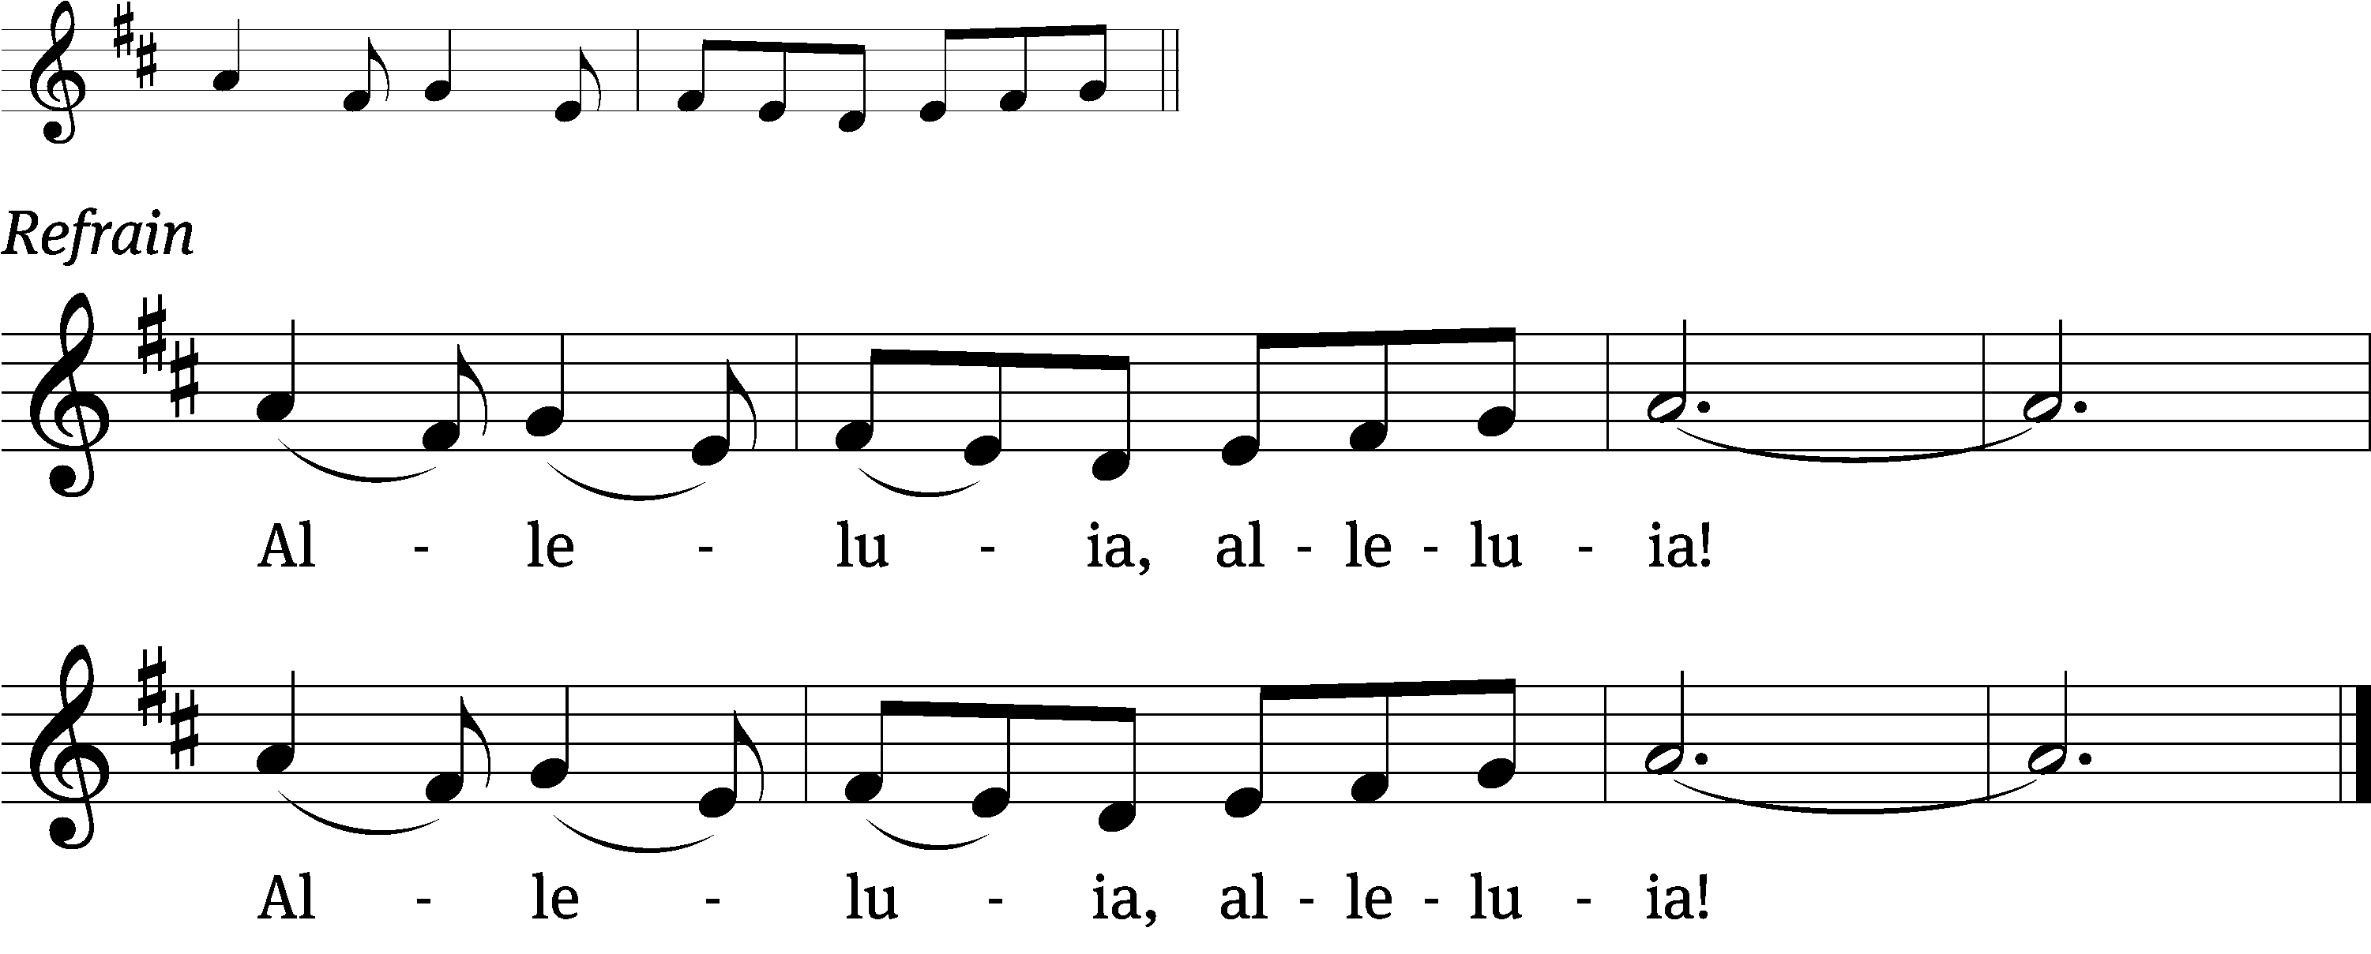
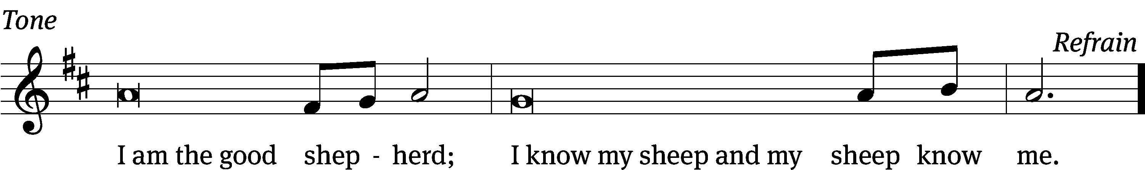
Tune: © 2010, 2021 GFTSMUSIC Publishing Company, Inc., admin. Music Services. Used by permission: OneLicense no. 716252

Gospel Reading
Both Jesus words and his works are identical to that of the Father, for he and the Father are one. Therefore, the protecting hand of the Good Shepherd is almighty.

John 10:22-30 (EHV)
²² Then the Festival of Dedication took place in Jerusalem. It was winter, ²³ and Jesus was walking in the temple area in Solomon’s Colonnade.
²⁴ So the Jews gathered around Jesus, asking, “How long will you keep us in suspense? If you are the Christ, tell us plainly.”
²⁵ Jesus answered them, “I did tell you, but you do not believe. The works I am doing in my Father’s name testify about me. ²⁶ But you do not believe, because you are not my sheep, as I said to you. ²⁷ My sheep hear my voice. I know them, and they follow me. ²⁸ I give them eternal life, and they will never perish. No one will snatch them out of my hand. ²⁹ My Father, who has given them to me, is greater than all. No one can snatch them out of my Father’s hand. ³⁰ I and the Father are one.”
L: The gospel of the Lord
C: Praise be to you, O Christ!
Please be seated

Behold a Host, Arrayed in White (Hymn 883, Blue hymnal)

Sermon
Revelation 7:9-17

Nicene Creed pg. 196 Blue hymnal
Please be seated

PRAYERS FOR HEALING OUR FAMILY & FRIENDS
Eva Andrews, John Allen, A.J. Betters, Gabrielle Blohowiak, Ashleigh Bourdelais, Dennis Brock, Terry Frossard, Geri Garbrecht, Emalee Gerhards, Dorothy Johnson, Rose Karr, Gary Ohrt, Lisa Schmitt, Pastor Sonnemann, Dean Tousey & Family, Ethan Peterson, and Dave Krzoska
PRAYERS FOR THOSE CALLED TO PROTECT
Military: Jesse Adams (Sue Connor’s son), Greg Carow (Dennis Carow’s godson/nephew), Aeron Forsberg (Linda and Gene Erickson’s grandson), Joshua Jansen (Isaac Jansen’s cousin), Jesse Johnston (Jim & Laurie Johnston's son), Dacien Konell (Linda and Gene Erickson’s grandson), Brock Miller (Jenna Miller’s brother), Patrick Noppenberg (Denis & Deb Vieth’s son) Thomas Weirich (Mary Bush’s nephew), Aaron Wood (Hope Wood's brother), and Dominic Paradiso. Firefighter: Steve Campbell. Police: Greg Haemker and Raymond Cashaw (Pastor Sonnemann's niece's husband).
Offering

Please rise

The Sacrament…………………………………..………………..pg. 199
Holy, Holy, Holy………………………………………….………pg. 200
Prayer of Thanksgiving…………………………………………..pg. 201

The Lord’s Prayer:
Our Father, who art in heaven, hallowed be thy name,
thy kingdom come, thy will be done on earth as it is in heaven.
Give us this day our daily bread; And forgive us our trespasses,
as we forgive those who trespass against us; And lead us not into temptation, but deliver us from evil. For thine is the kingdom
and the power and the glory, forever and ever. Amen.

The Words of Institution
P: Our Lord Jesus Christ, on the night he was betrayed, took bread; and when he had given thanks, he broke it and gave it to his disciples, saying, “Take and eat; this is my body, which is given for you. Do this in remembrance of me.”

P: Then he took the cup, gave thanks, and gave it to them, saying, “Drink from it, all of you; this is my blood of the new covenant, which is poured out for you for the forgiveness of sins. Do this, whenever you drink it, in remembrance of me.”
P: The peace of the Lord be with you always.
C: Amen.

The Lamb of God (Agnus Dei)…………………………………pg. 202
Please be seated

The Lord’s Supper – Distribution

Please rise
P: Give thanks to the Lord, for he is good;
C: his mercy endures forever.
P: Whenever we eat this bread and drink this cup,
C: we proclaim the Lord’s death until he comes.
P: O God the Father, source of all goodness, in your loving-kindness you sent your Son to share our humanity. We thank you that through him you have given us pardon and peace in this Sacrament. We also pray that you will not forsake us but will rule our hearts and minds by your Holy Spirit so that we willingly serve you day after day; through Jesus Christ our Lord, who lives and reigns with you and the Holy Spirit, one God, now and forever.
C: Amen.

Benediction:
P: The Lord bless you and keep you.
The Lord make his face shine on you and be gracious to you.
The Lord look on you with favor and give you peace.
C: Amen.
Please be seated

Lord, When Your Glory Shall I See (Hymn 884, Blue hymnal)

Trinity announcements

Students of the Week TLS’s students of the week include: Ben Marklein, Mason Peterson, Jaxon Larson, Ariel Nelson.

Graduation Service- Thursday, May 26 at 6:30pm is the graduation worship service for TLS’s 8th grade students here at church. Everyone is welcomed to attend!

Confirmation Worship Service- next Sunday, May 15th will be the service for confirming this year’s confirmands. Please come and witness their statements of faith.
VBS Volunteers: You’ve all heard the saying, “it takes a village to raise a child” here at Trinity is takes a congregation to run VBS. We’re running a Monumental VBS! We’ll explore the sunbaked Southwestern desert and dig into God’s great love! You have an opportunity the week of VBS (July 25th – 29th 9am-12pm.) to assist with: crew leaders, station leaders and the registration table. Or if working with children isn’t your thing we also need volunteers for: hanging door hangers, registration table, setup, and cleanup too!

Food Pantry - Our food pantry is a great way to give back to the community and to bring new people into Trinity.
Cleaning Supplies Needed—We’re running short of tissues and paper towels. If you could provide either or both, please bring them to church and put them into the blue buckets in the entry or downstairs on one of the tables. Thank you!
Taste of Missions -- Registration is now open for Taste of Missions, a hybrid event that will be held on Saturday, June 11, 2022 at Wisconsin Lutheran Seminary in Mequon, WI. Join us in person OR online to get a “taste of missions” no matter where you might be around the world. It’ll be a fun day of ethnic food from our mission fields, fellowship with our home and world missionaries, and activities for the entire family. Virtual attendees will be able to watch all events via livestream and view additional video updates and recipes from missionaries on the website. You can find all the details and the full itinerary at tasteofmissions.com.
Luther Prep Summer Camps—LPS Summer Camps are in full planning mode and we hope to see more of your children join us! We offer Day Camps & Overnight Camps for a variety of sports and for the 2nd year in a row, our new Phoenix Adventure Camp!

Worship Services

Sunday at 9:00am & Monday at 6:00pm

Or watch online at: www.youtube.com/user/PastorTesch

Those serving in our Lord’s house
Pastor Jon Tesch
Lector: Pastor Tesch Music: Barb Tesch
Camera: Dominic Nelson Projector Operator: Lyla Koeffler
Ushers: Team 1

Cleaning Team: May 7-8: Amanda DeJardin, Jeremy Vieth, Jessie Dembroski

Offerings support our ministry, operations, and outreach for Trinity Lutheran Church and School. This QR code will direct your phone or tablet to our electronic giving site. This site gives you the flexibility of either one-time offerings or recurring contributions. Alternatively, you can visit trinitymarinette.com.

✟ Next week at a glance ✟

Sunday, May 8th
Communion Worship Service 9:00am
Bible Class 10:15am

Monday, May 9th
Worship Service 6:00pm

Tuesday, May 10th
Food Pantry 10am-12pm
Praise Team 6:00pm

Wednesday, May 11th
TLS Chapel Service 8:10am
Catechism…………………………………………………..3:30pm

Thursday, May 12th
Food Pantry 1pm-3pm

Sunday, May 15th
Confirmation Worship Service 9:00am
Bible Class 10:15am

Those serving in our Lord’s house Next Week
Pastor Jon Tesch
Lector: Al Walker Music: Anne Krzoska
Camera: Mariah Salewsky Projector Operator: John Brattain
Ushers: Team 2

Cleaning Team: May 14-15: Joan Hetcher, Lora & Steve Herbst, Mike & Arlene Hoard

